Objective 1

See Attached Lumira File titled VollkommerObjective1

Objective 2

XBX 360 corrected to XBOX 360

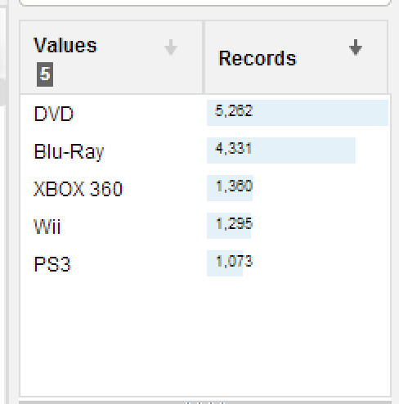

Create Rating Description

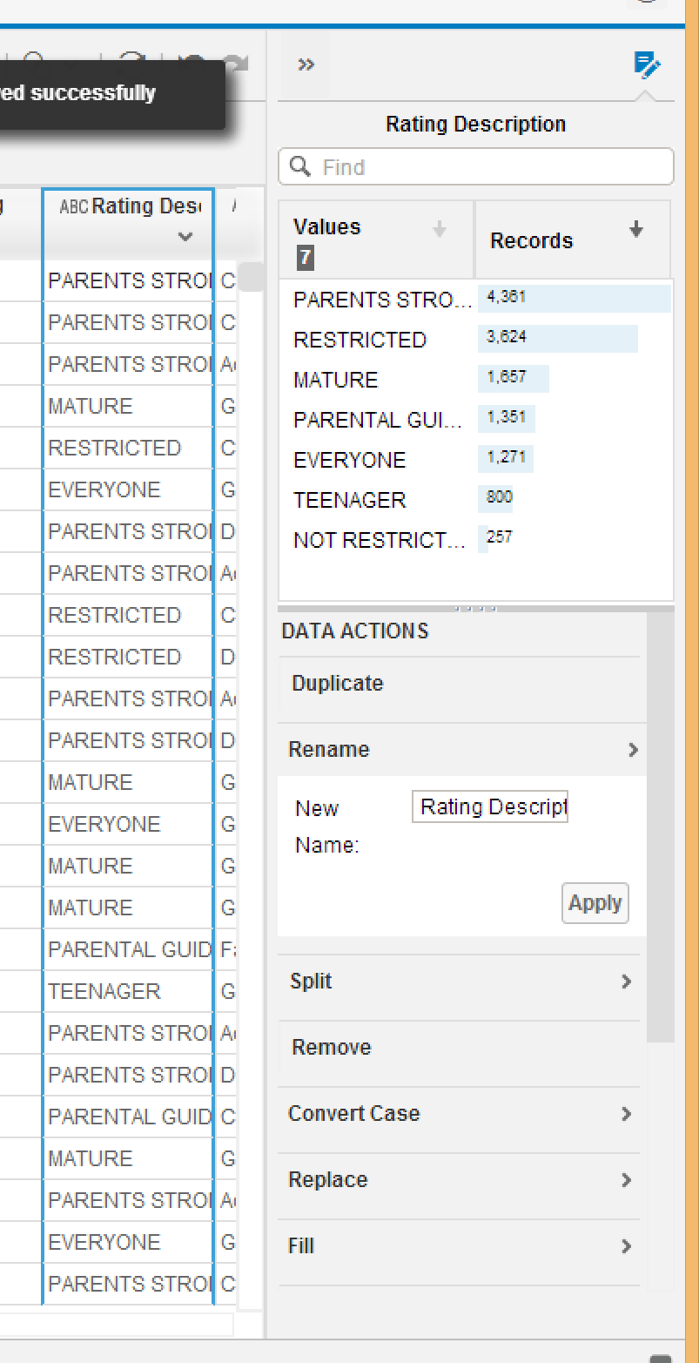

Date and Geo Hierarchy

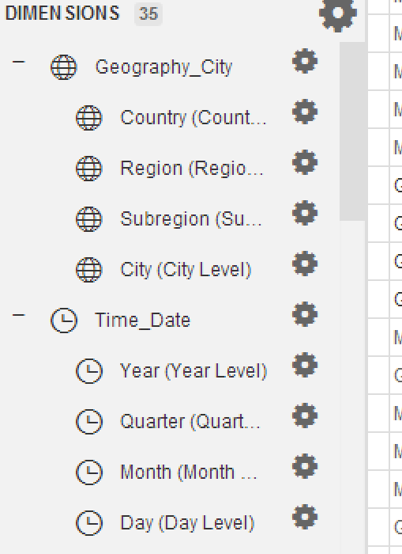

Disc Type

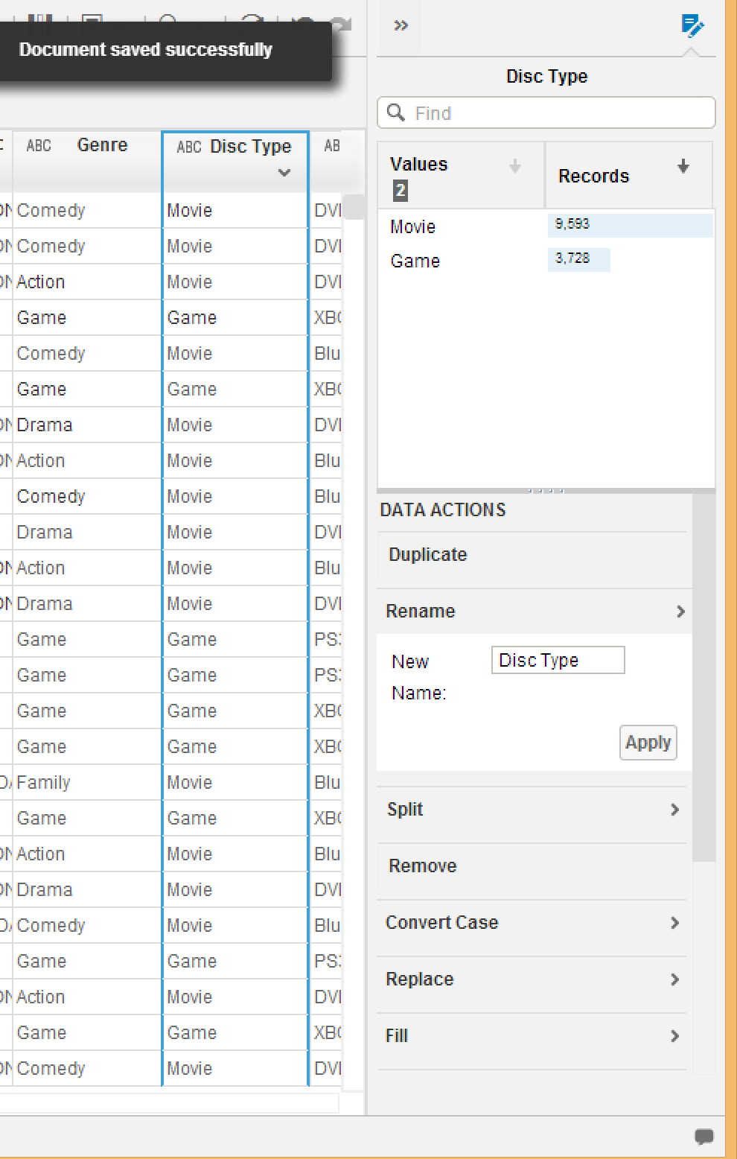

Zip-10

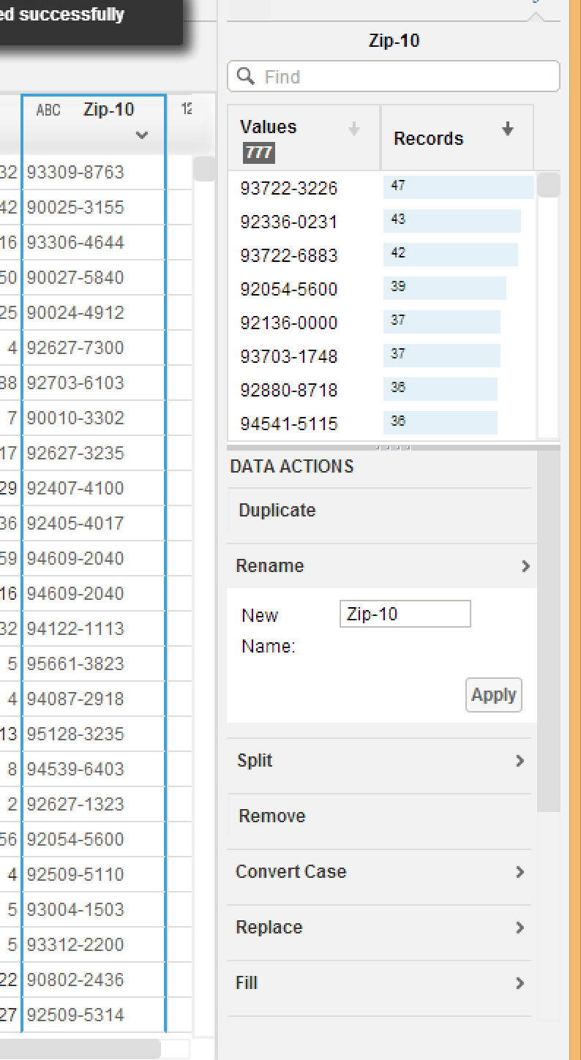

Custom Calculation

Length({Box ID})

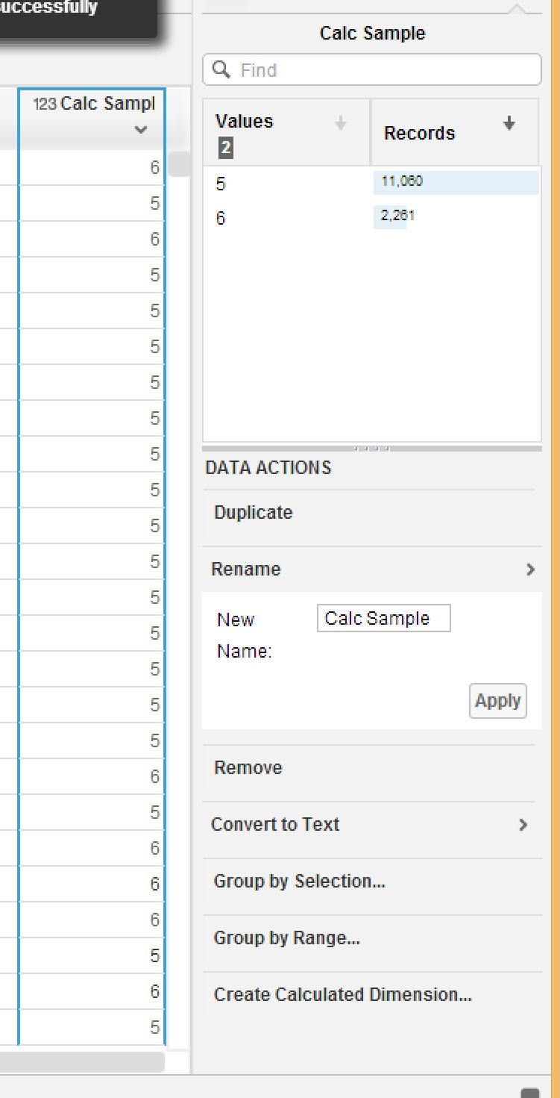

Walmart and Circle K Filter

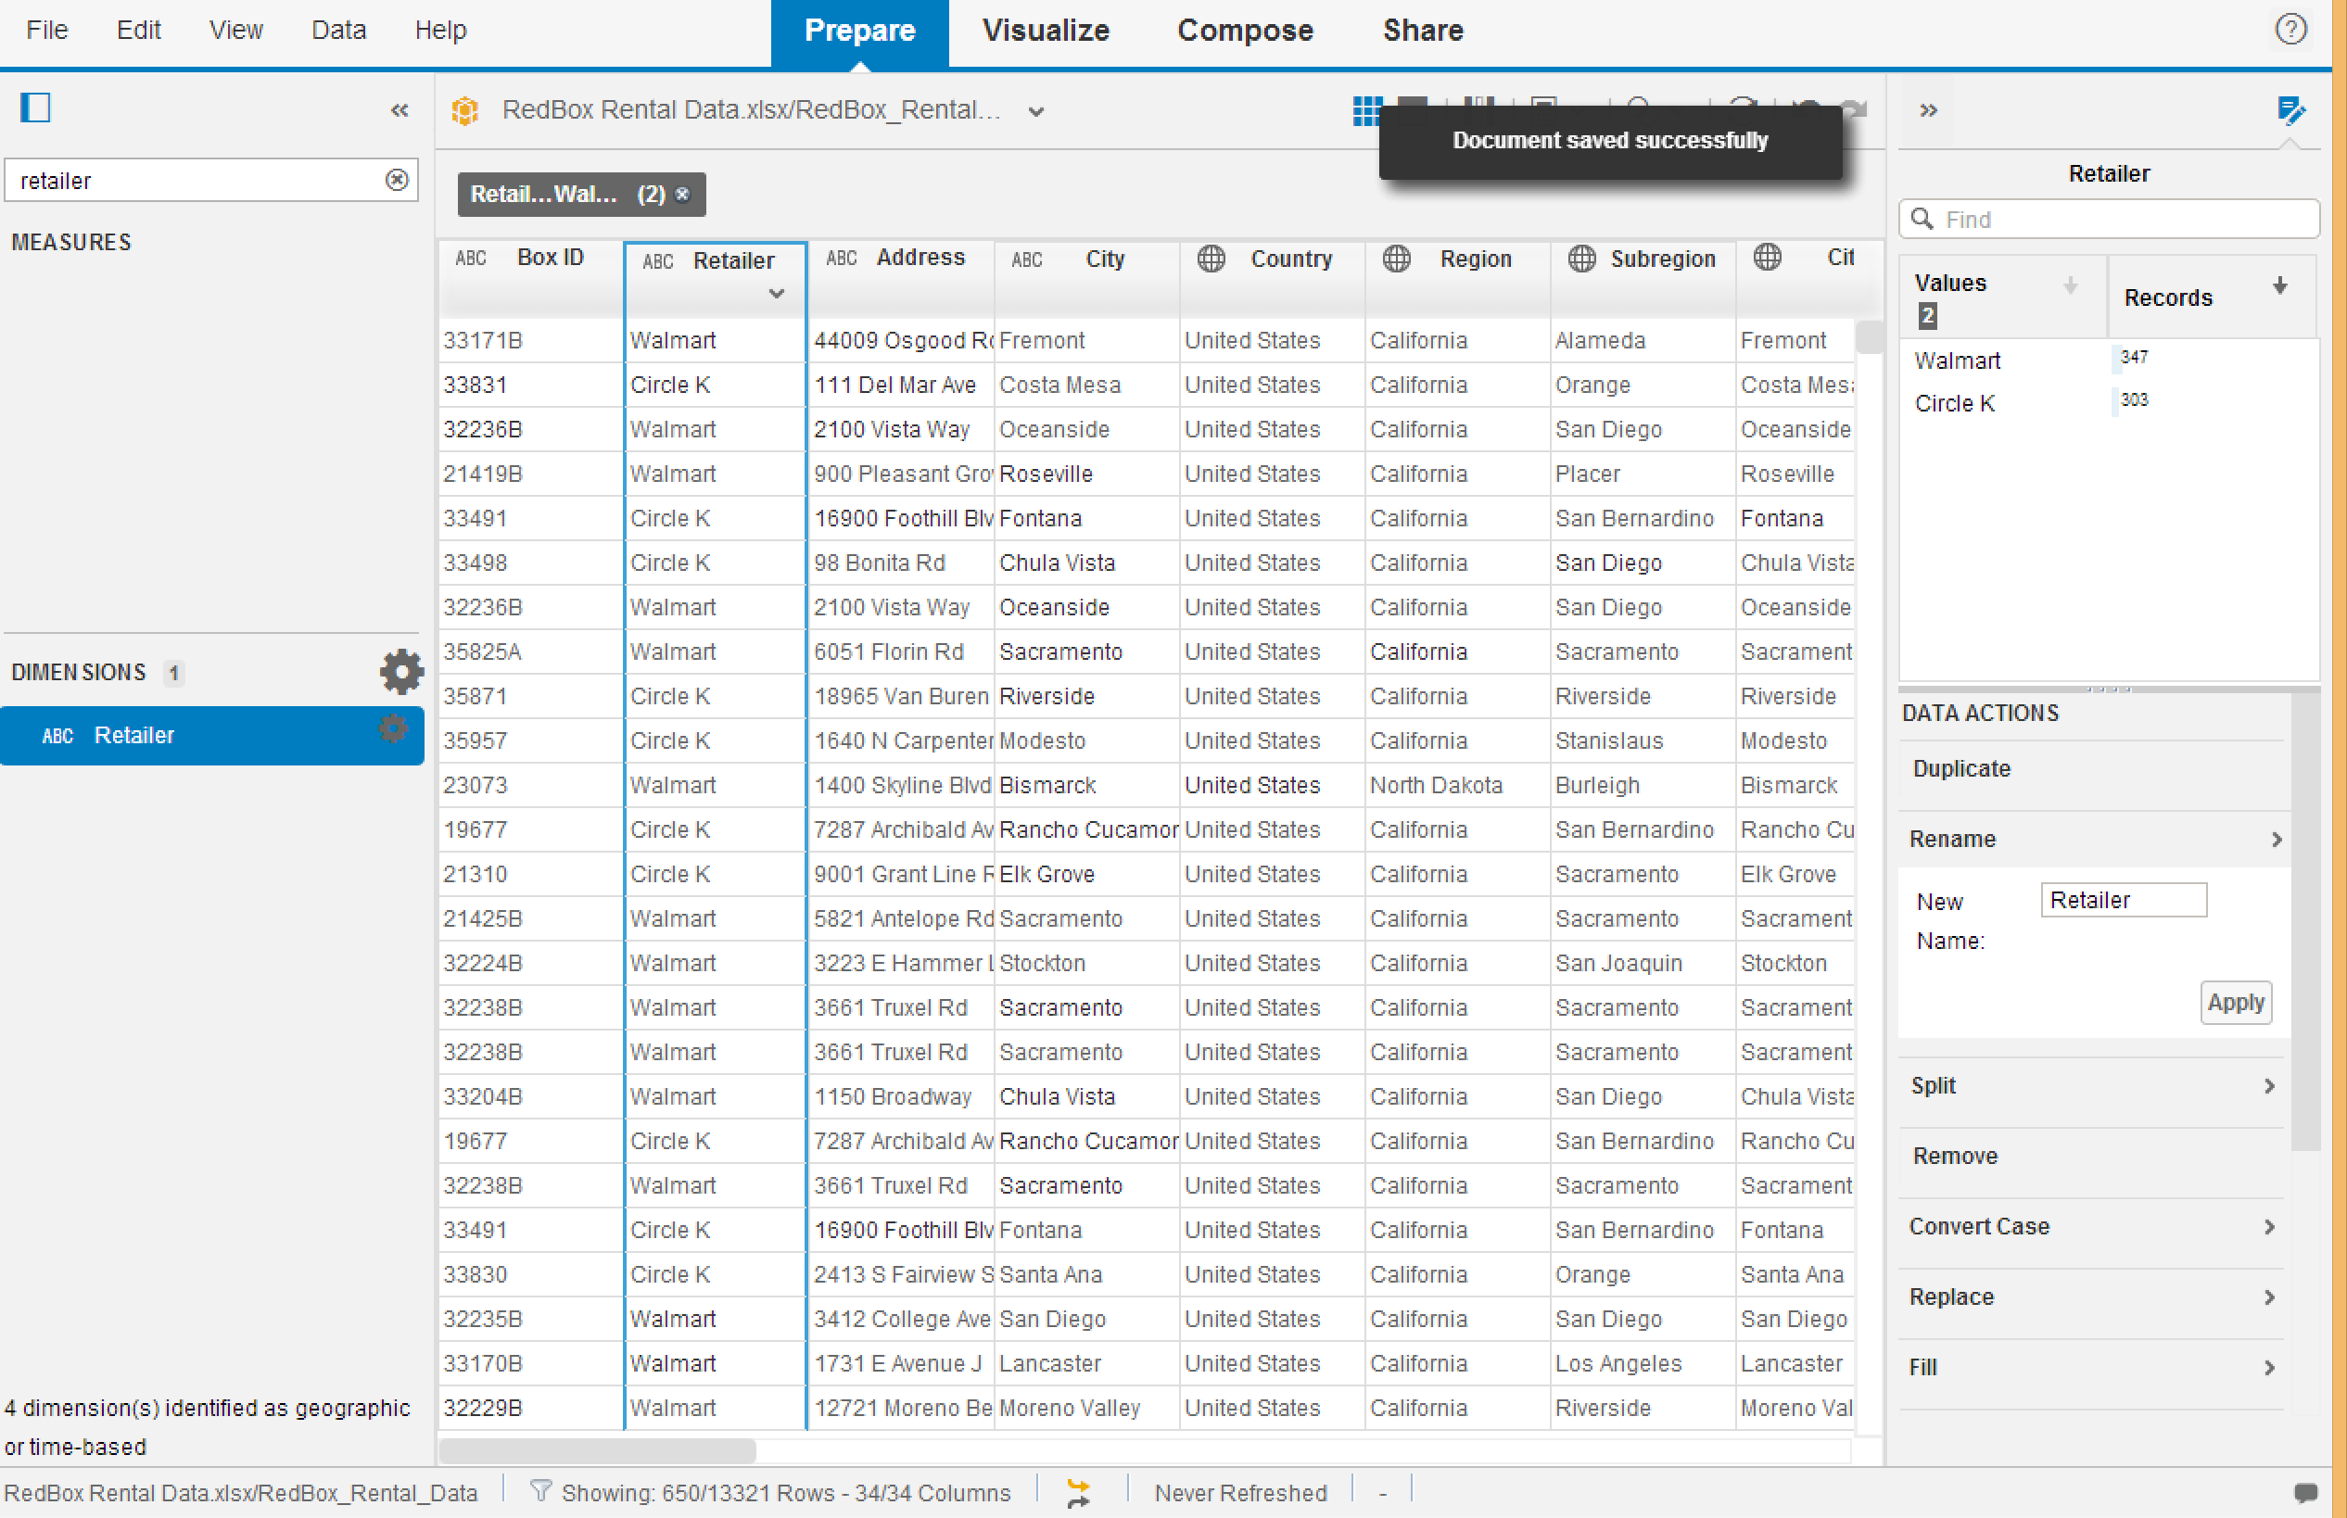

Added Random Data

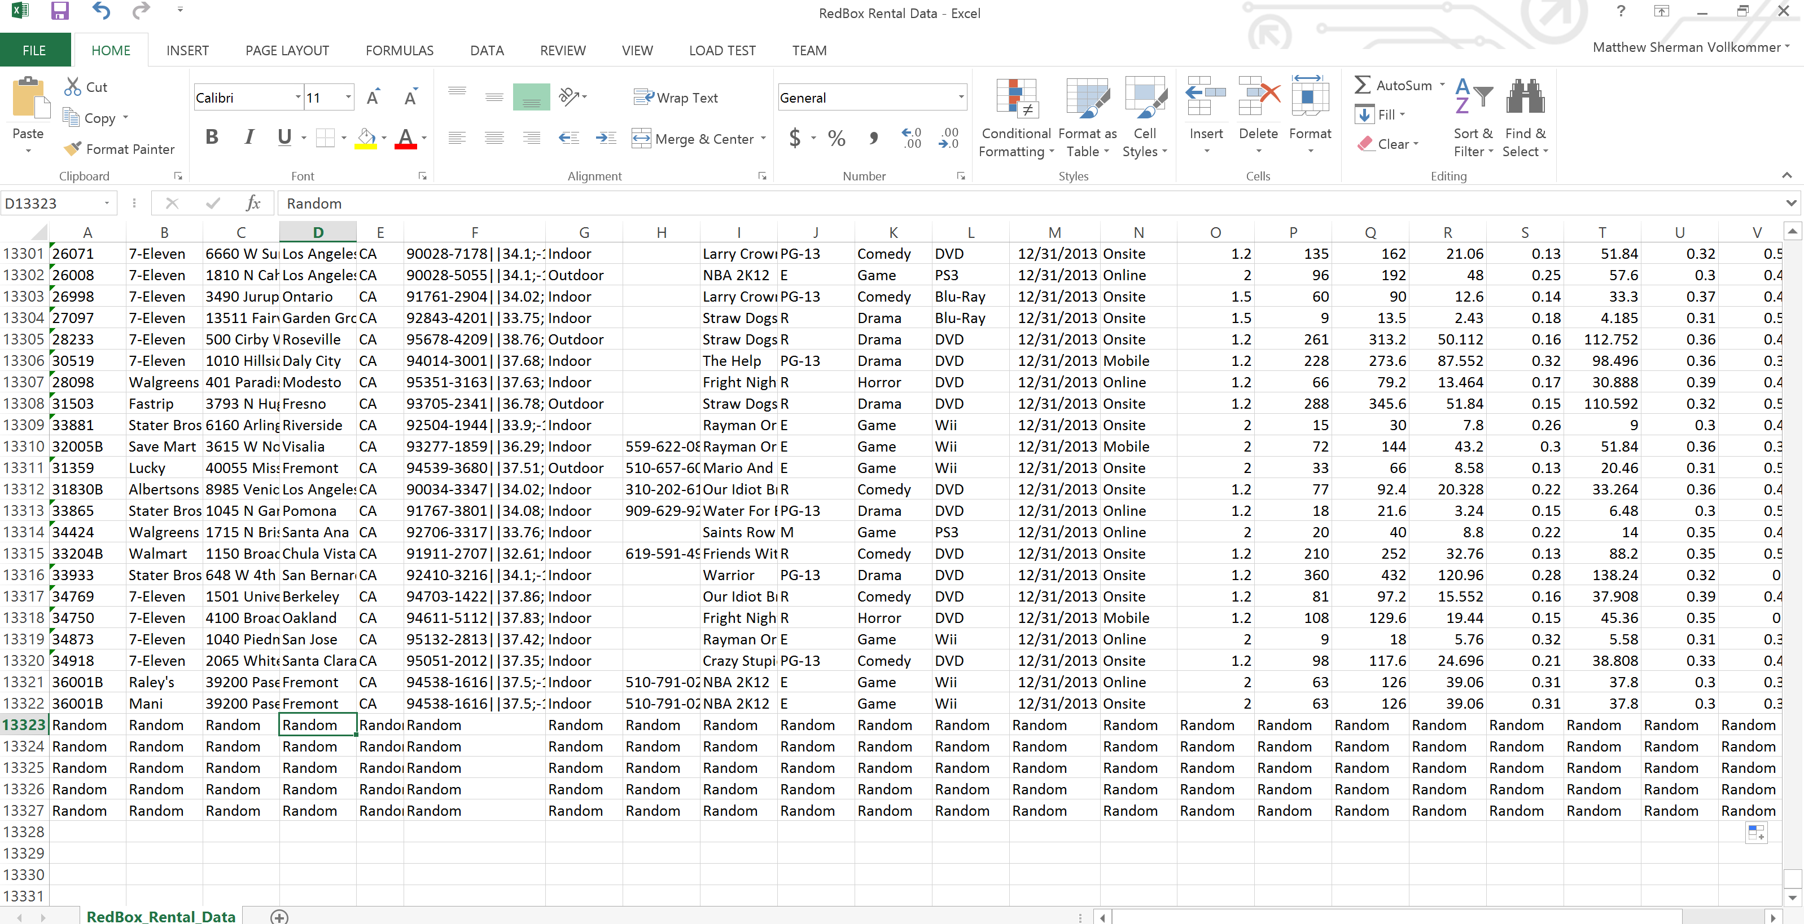

Data Refreshed



Random Data added

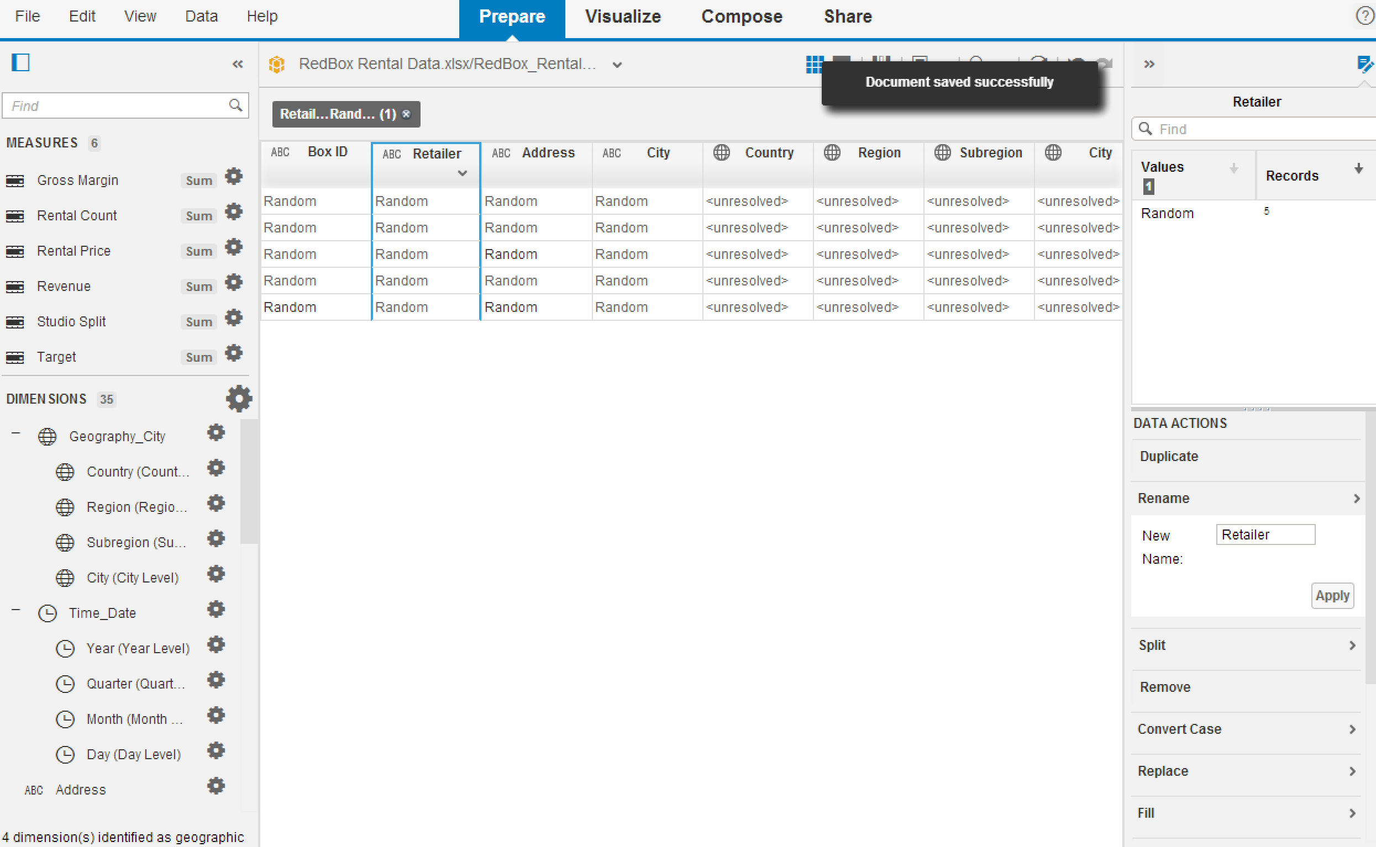

File Saved and attached as VollkommerObjective2

Question: How many rows containing “XBOX 360” are there in your data set?

1,360

Question: How many movies versus games are in your data set?

9,593 Movies and 3,728 Games.

Did you create a calculated dimension or measure?

I created a calculated Dimension

What formula did you create?

SubString( {Zip_Augmented}, 0, 10)

Objective 3

Question: Which disc type is most exceeding its target?

DVD is exceeding its target gross margin the most, by about $40,000.

How are we reserving discs?” Rentals are made more onsite than on mobile and online combined.

What insight into how customers reserve rentals can you discern?

Our Customers prefer to make rentals onsite.

Is there an outlier on the correlation between revenue and rental price?

Yes, the game genre appears to be an outlier.

Below are all charts/graphs made in objective 3

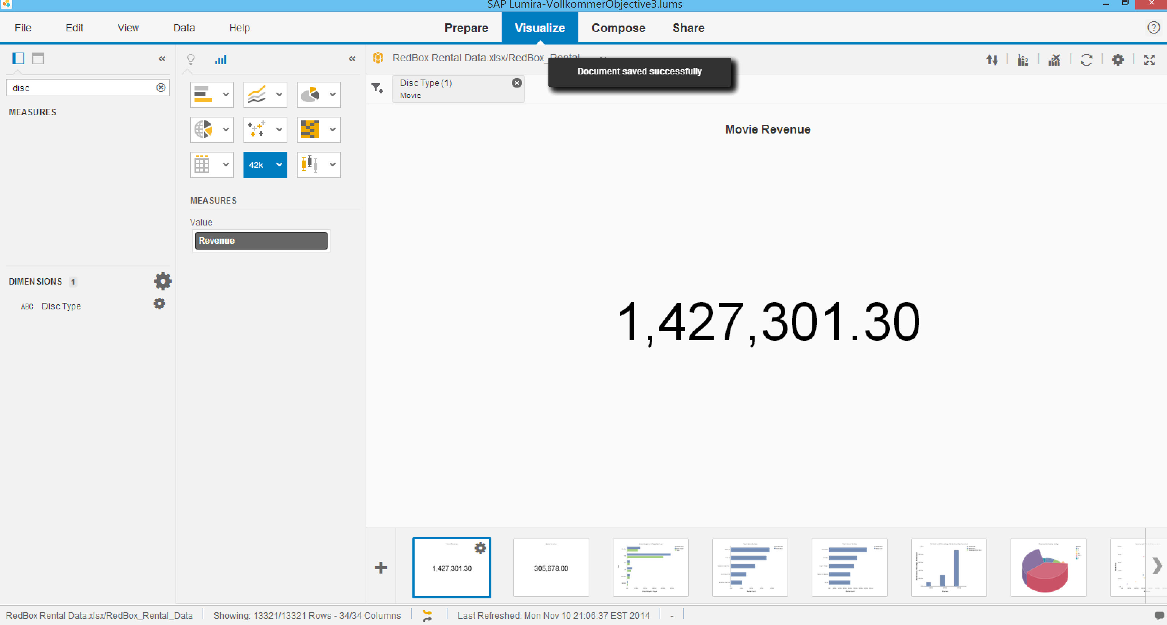

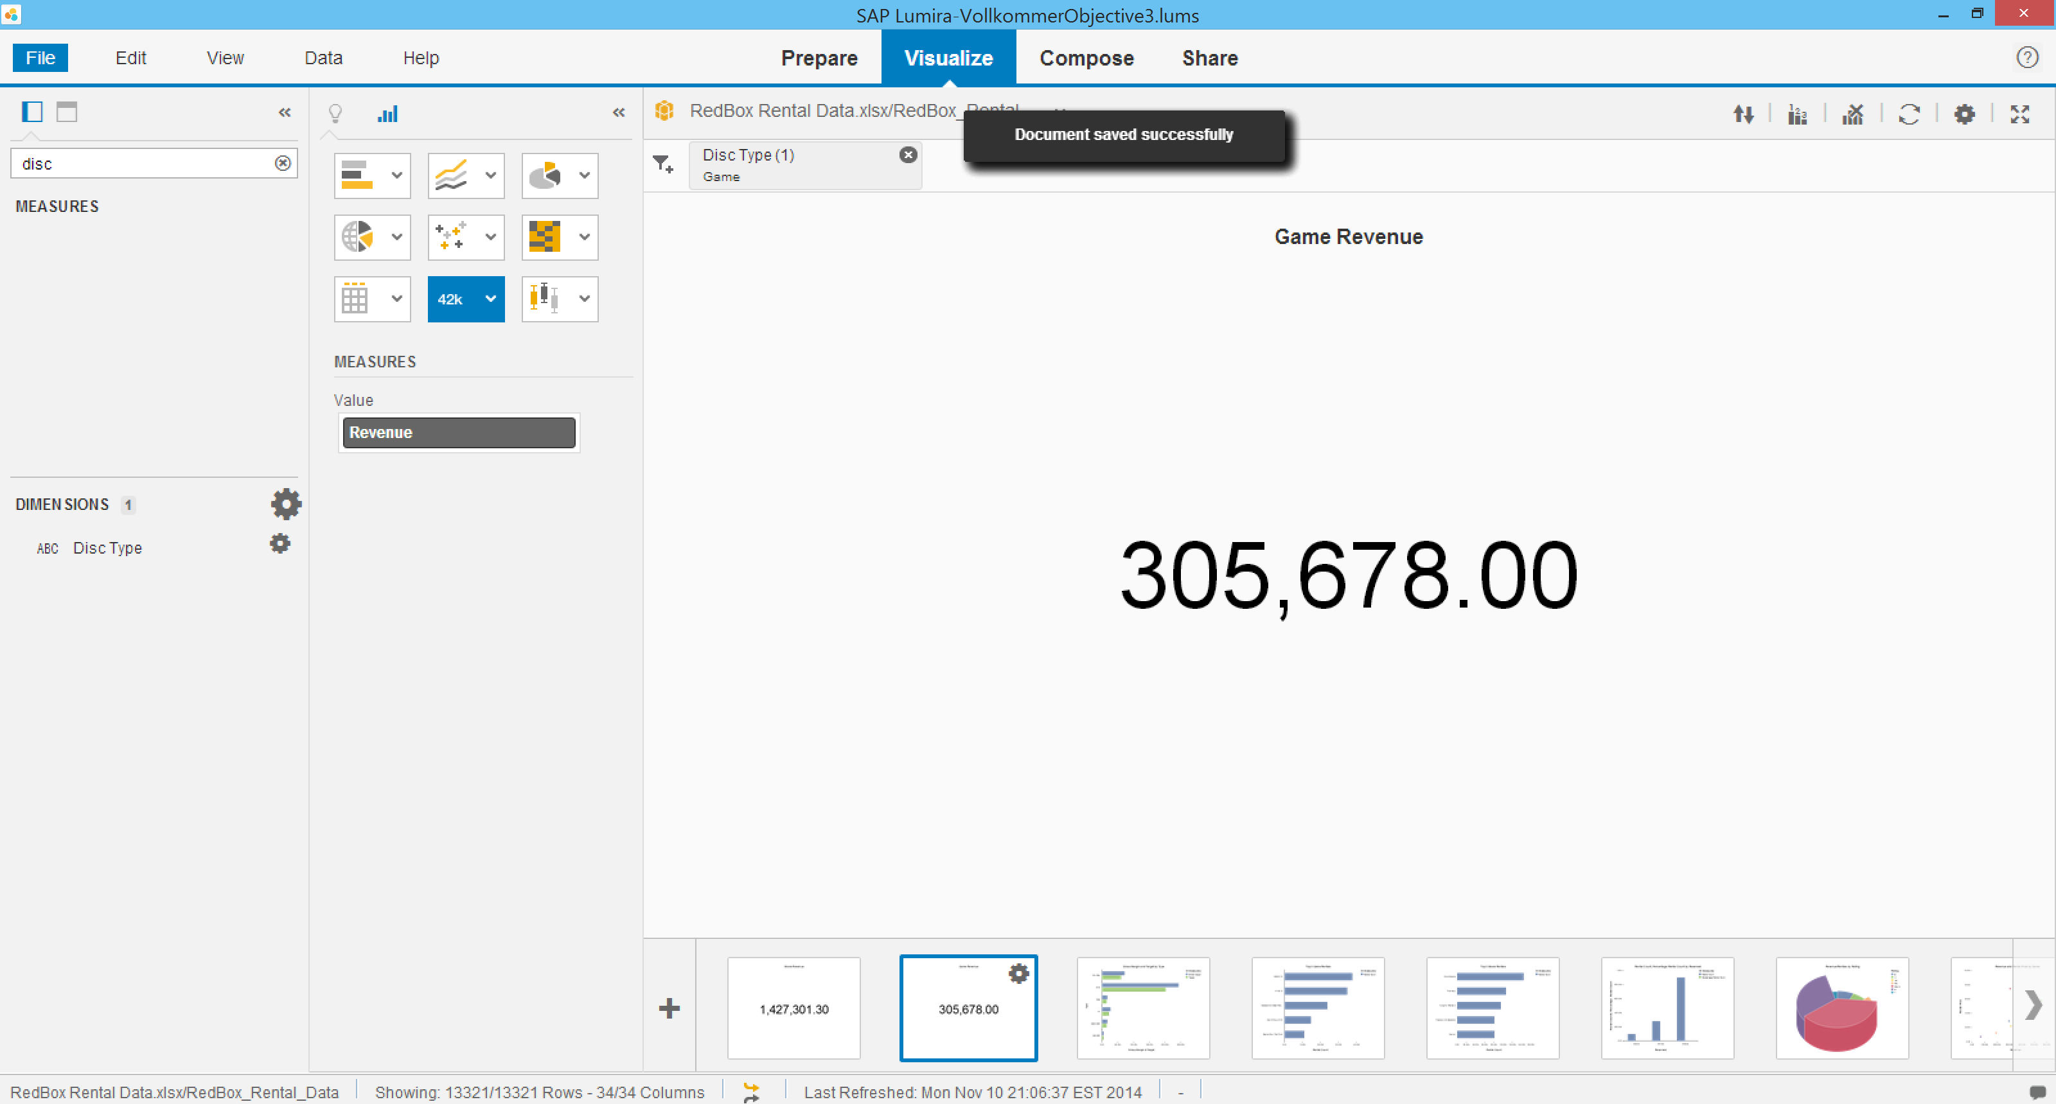

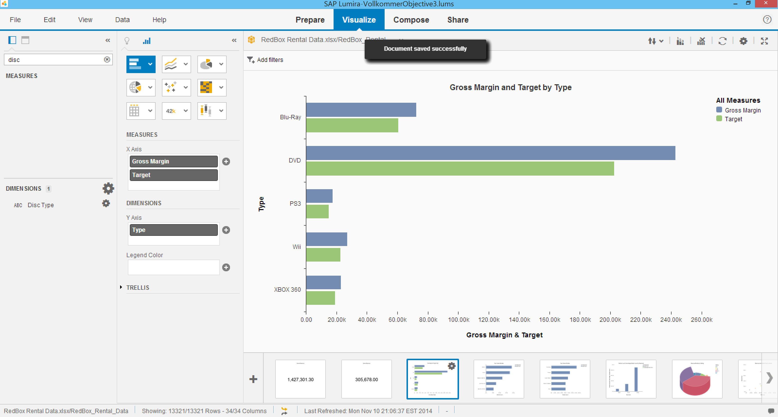

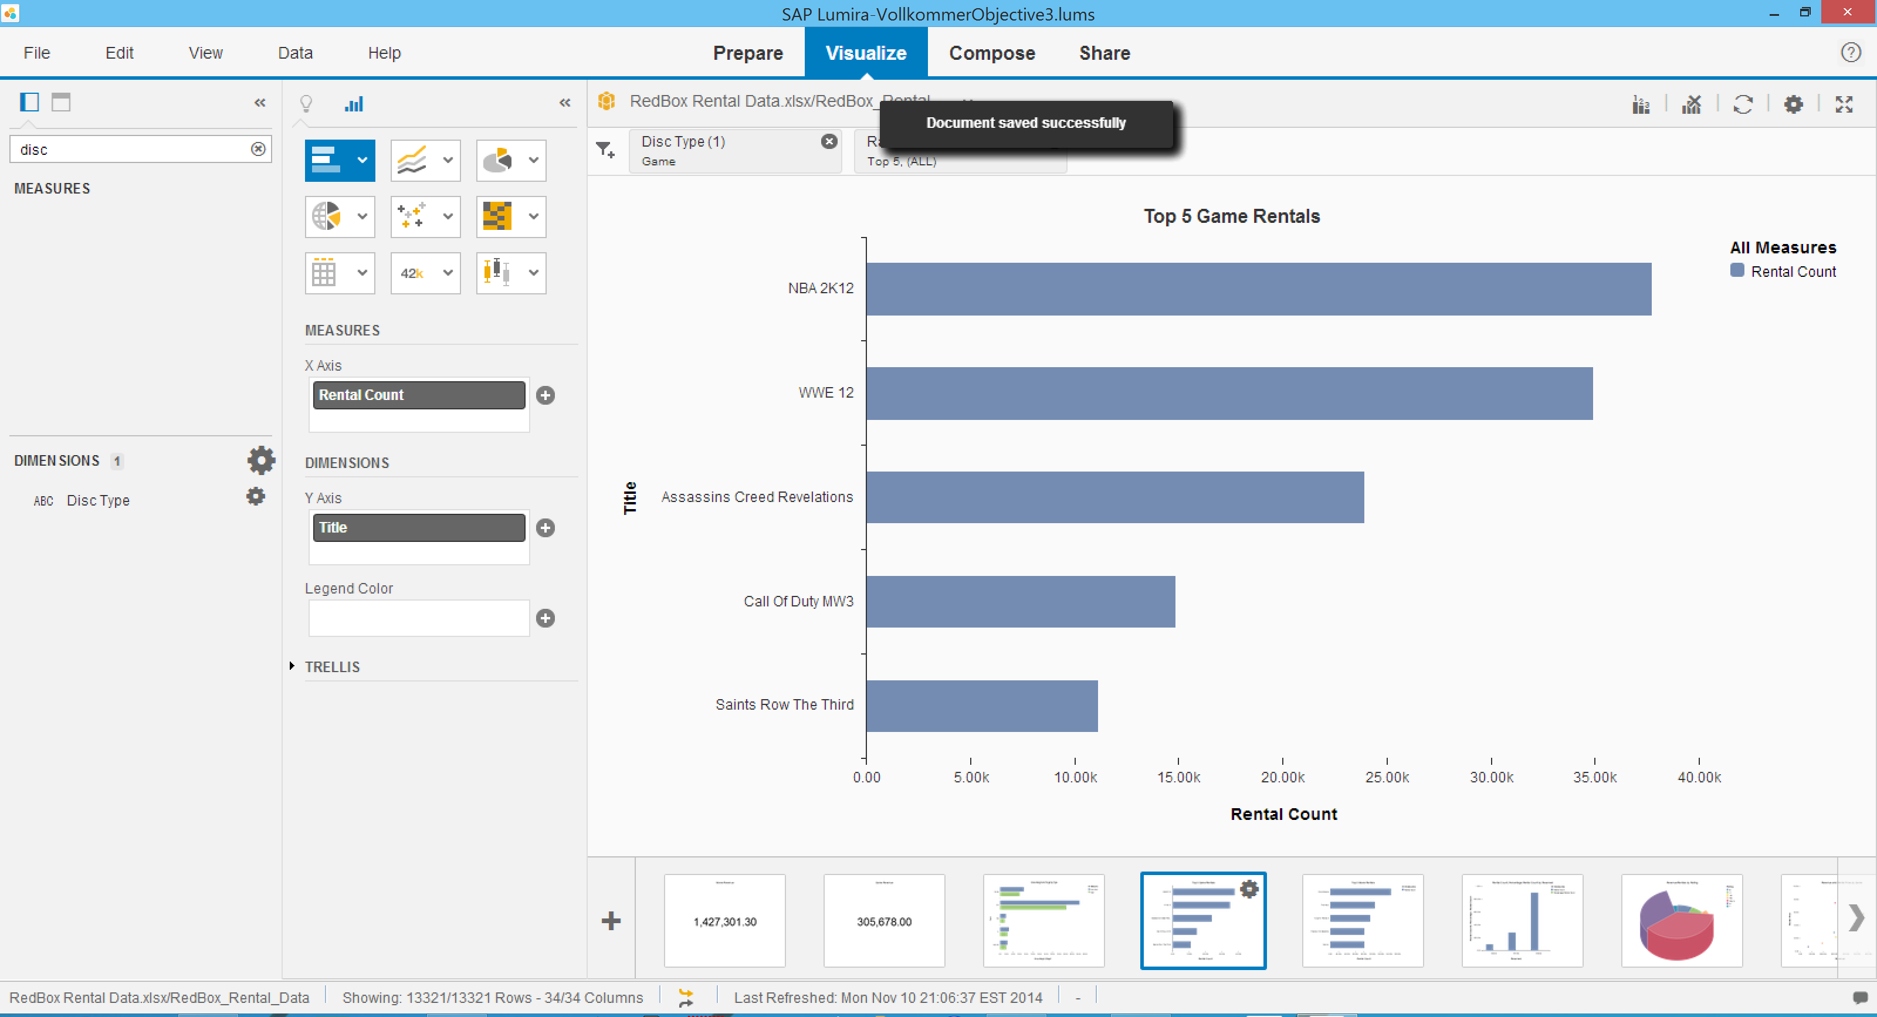

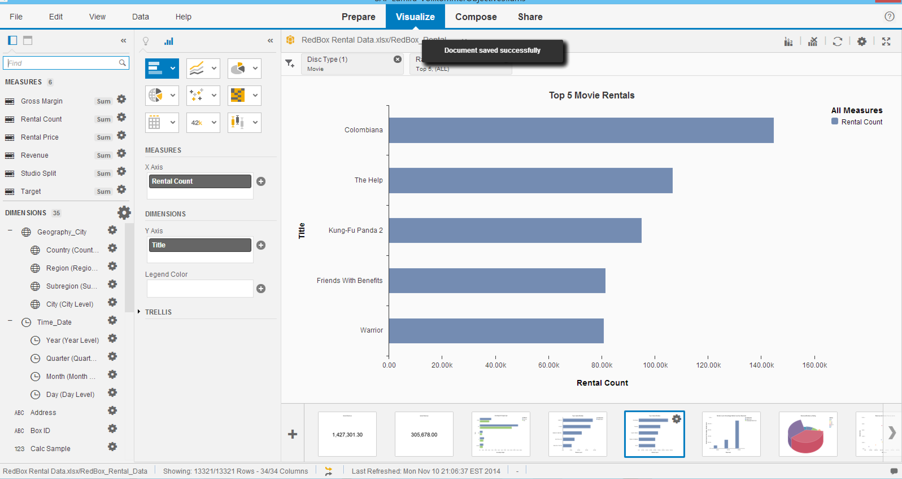

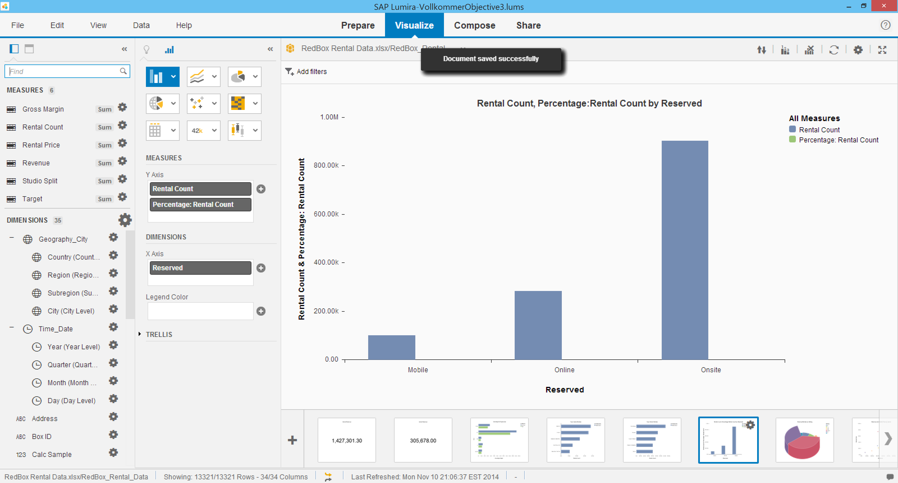

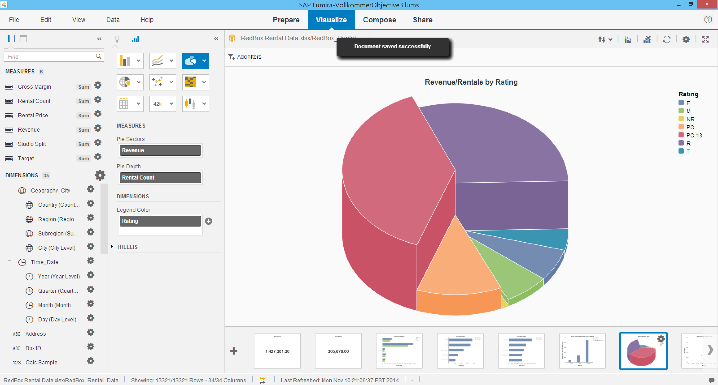

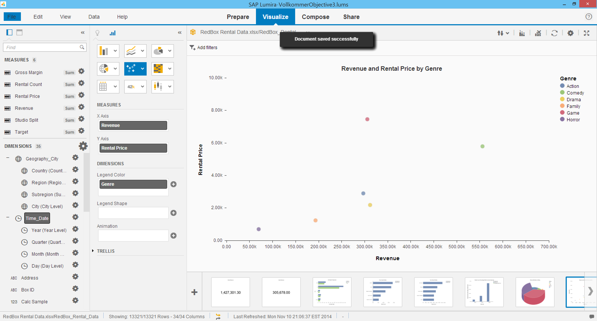

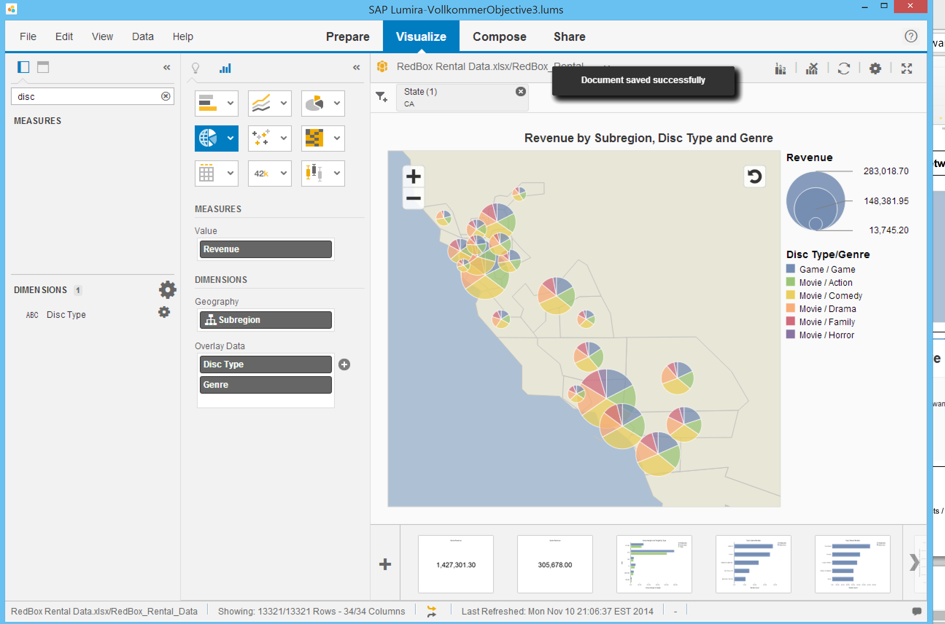

Objective 4

Storyboard on Lumira

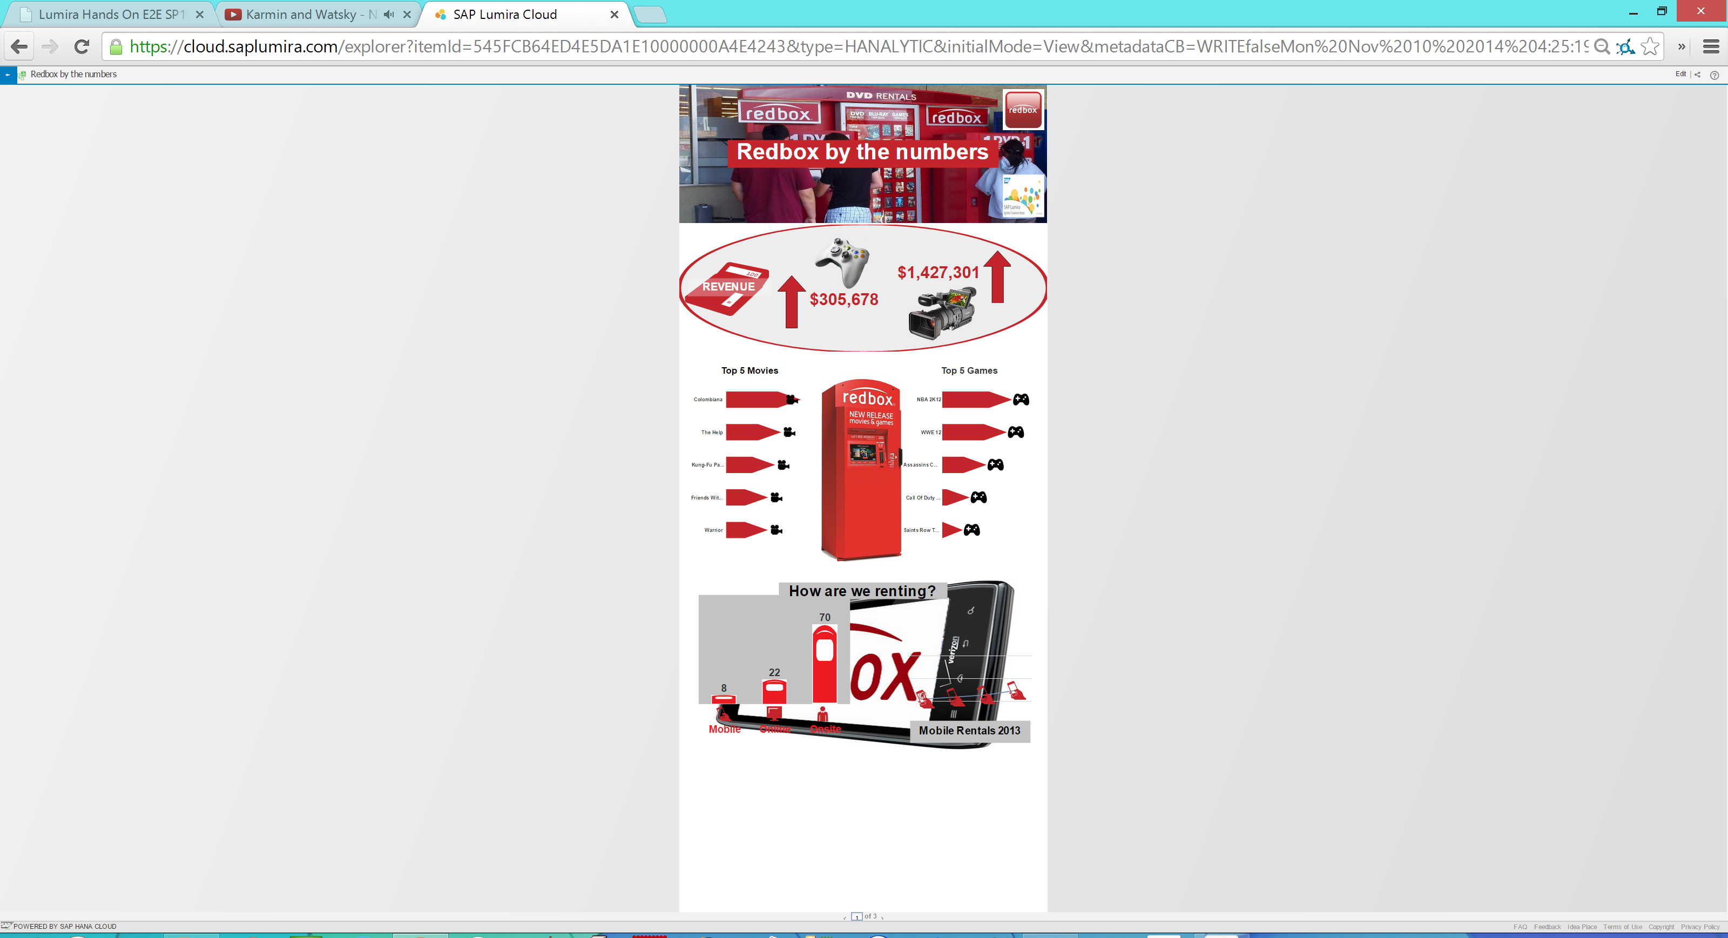

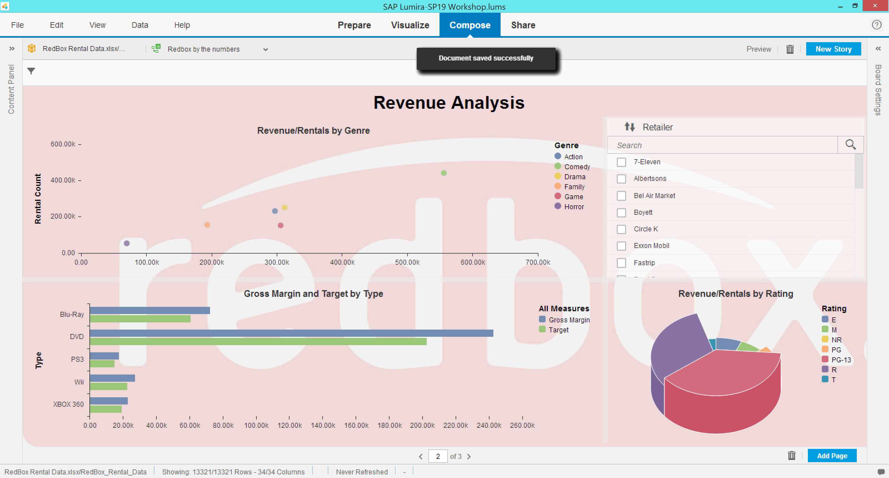

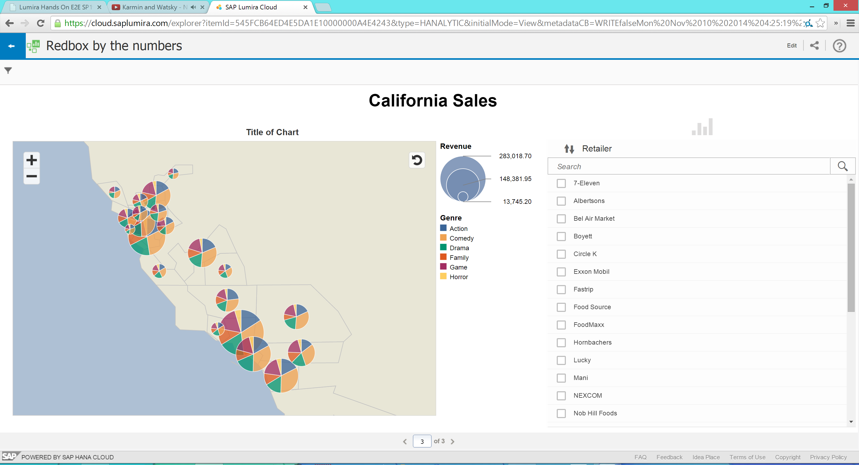

Write 1-2 paragraphs in which you describe your general impression of Lumira. How does it compare to other software we've used. What do you like/dislike about it? Should I continue to include this software project in this course? Any other comments.

I really enjoyed Lumira. I liked it better than the other software we have surveyed, including tableua. I find its data cleansing capabilities to be powerful and useful. I dislike that there were some bugs dealing with text boxes not disappearing. However, this is probably due to the retina-esque resolution of my laptop. I believe that we should learn each software like we did with Lumira, a guided self-study. And then we should do detective work with different data sets and present it as a group as we did in the tableau project. I think that would be the best way to learn the material and have experience using it in an ambiguous environment.